WHAT IS SOURCE CODE MANAGEMENT?
Source code management originates from revision control, which is the management of changes for e.g. books or source code. Usually revisions are identified by a revision number. They are also associated with a timestamp and a sign of the originator. Due to revision control it is possible to work on one document with multiple users. A user can create a local working copy” by checking out the document.
Source code is stored in so called repositories. If several people are working on one document simultaneously the changes are checked in chronologically.
Source code management tools are specialized in revision control for software development. In general two different kinds of revision control can be distinguished: centralized and distributed systems.

CENTRALIZED REVISION CONTROL SYSTEMS
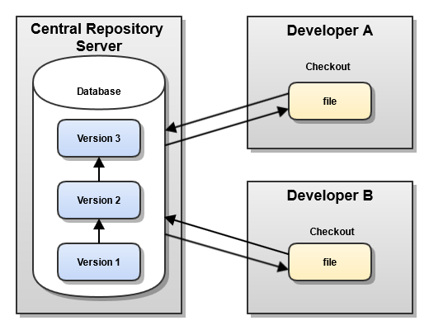
Centralized revision control systems are storing all source code in one, central location. A developer checks out source code, makes changes and commits them. By committing the changes they get incorporated in the central location. This approach guarantees that the source code can always be found in one place. Therefore developers don´t have to keep many different copies of the source code on their local drives. If you want to save changes to a repository by committing, you have to be connected to the server. Common centralized version control systems are CVS and Subversion (SVN).

DISTRIBUTED REVISION CONTROL SYSTEMS
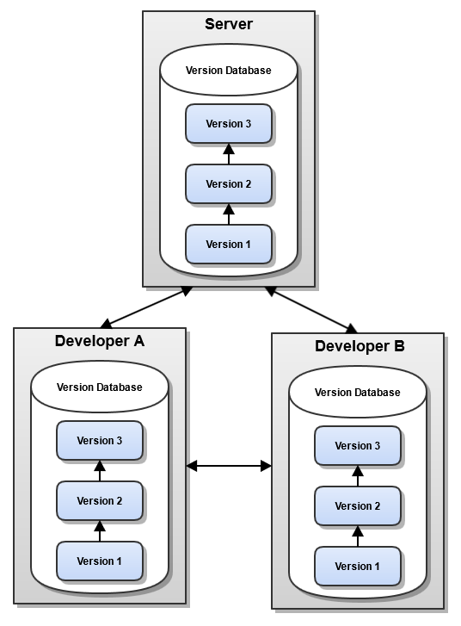Distributed revision control systems came up in 2005. The main difference to centralized systems is, that they do not necessarily store all the revisions on one central server. Every developer clones a copy of a repository and has the full history of the project on his hard drive. This method results in a bigger amount of required disk space, but since that is so cheap nowadays, this is not a problem. A developer can “pull” the latest versions of repositories to his hard drive, make changes and “push” them to other developers. Common distributed revision control systems are Git and Mercurial.

ADVANTAGES OF DVCS
- Committing changes to the local copy is very fast, because only the local hard drive, instead of a remote server, needs to be accessed.
- Commits can be done without anyone else noticing it. Others can only access changes after they were pushed.
- Check outs and commits can be done without a permanent connection to the server.
- It is possible to edit commits and tidy up the local history of changes before they are published.
- Every user can hold a copy of the whole project as backup.

DISADVANTAGES OF DVCS
- The first pull of a project can contain many large binary files and can therefore take a while.
- Large projects need a large amount of disk space or special treatment to pull only required elements of the whole project.

What Is Git ? – Explore A Distributed Version Control Tool
Git is a free, open source distributed version control system tool designed to handle everything from small to very large projects with speed and efficiency. It was created by Linus Torvalds in 2005 to develop Linux Kernel. Git has the functionality, performance, security and flexibility that most teams and individual developers need.
We all know “Necessity is the mother of all inventions”. And similarly Git was also invented to fulfill certain necessities that the developers faced before Git. So, let us take a step back to learn all about Version Control Systems (VCS) and how Git came into existence.
Version Control is the management of changes to documents, computer programs, large websites and other collection of information.
There are two types of VCS:
- Centralized Version Control System (CVCS)
- Distributed Version Control System (DVCS)

Centralized VCS
Centralized version control system (CVCS) uses a central server to store all files and enables team collaboration. It works on a single repository to which users can directly access a central server.
Please refer to the diagram below to get a better idea of CVCS:
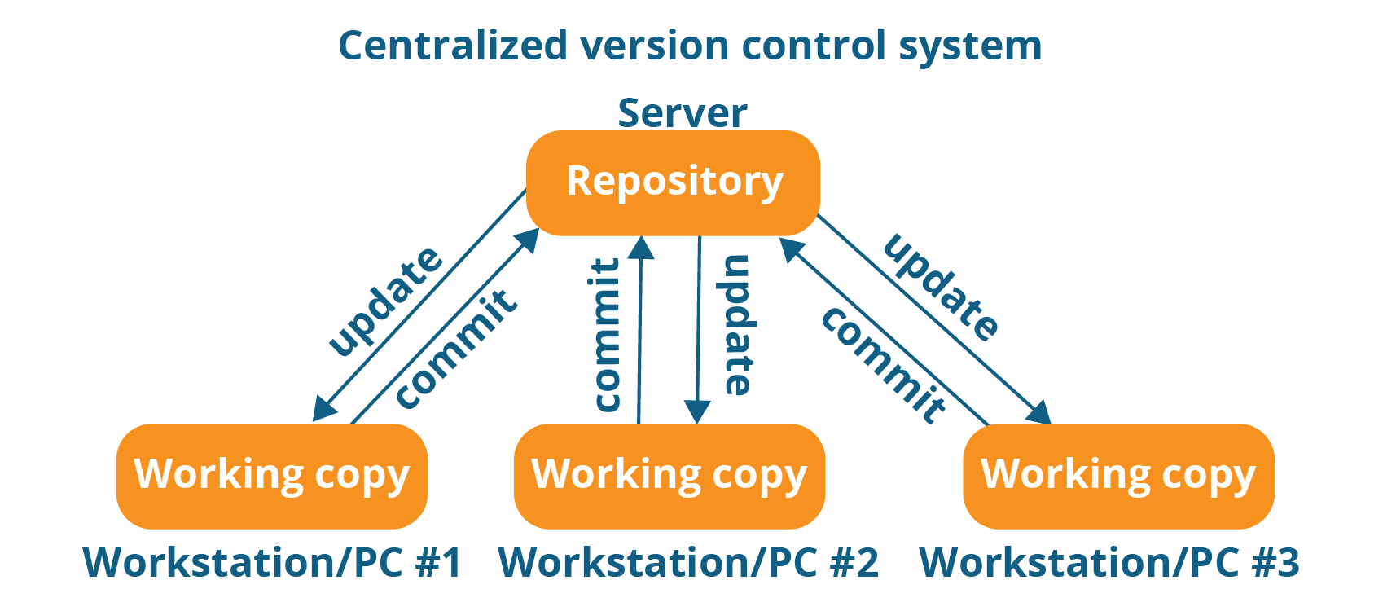
The repository in the above diagram indicates a central server that could be local or remote which is directly connected to each of the programmer’s workstation.
Every programmer can extract or update their workstations with the data present in the repository or can make changes to the data or commit in the repository. Every operation is performed directly on the repository.
Even though it seems pretty convenient to maintain a single repository, it has some major drawbacks. Some of them are:
- It is not locally available; meaning you always need to be connected to a network to perform any action.
- Since everything is centralized, in any case of the central server getting crashed or corrupted will result in losing the entire data of the project.
This is when Distributed VCS comes to the rescue.

Distributed VCS
These systems do not necessarily rely on a central server to store all the versions of a project file.
In Distributed VCS, every contributor has a local copy or “clone” of the main repository i.e. everyone maintains a local repository of their own which contains all the files and metadata present in the main repository.
You will understand it better by referring to the diagram below:
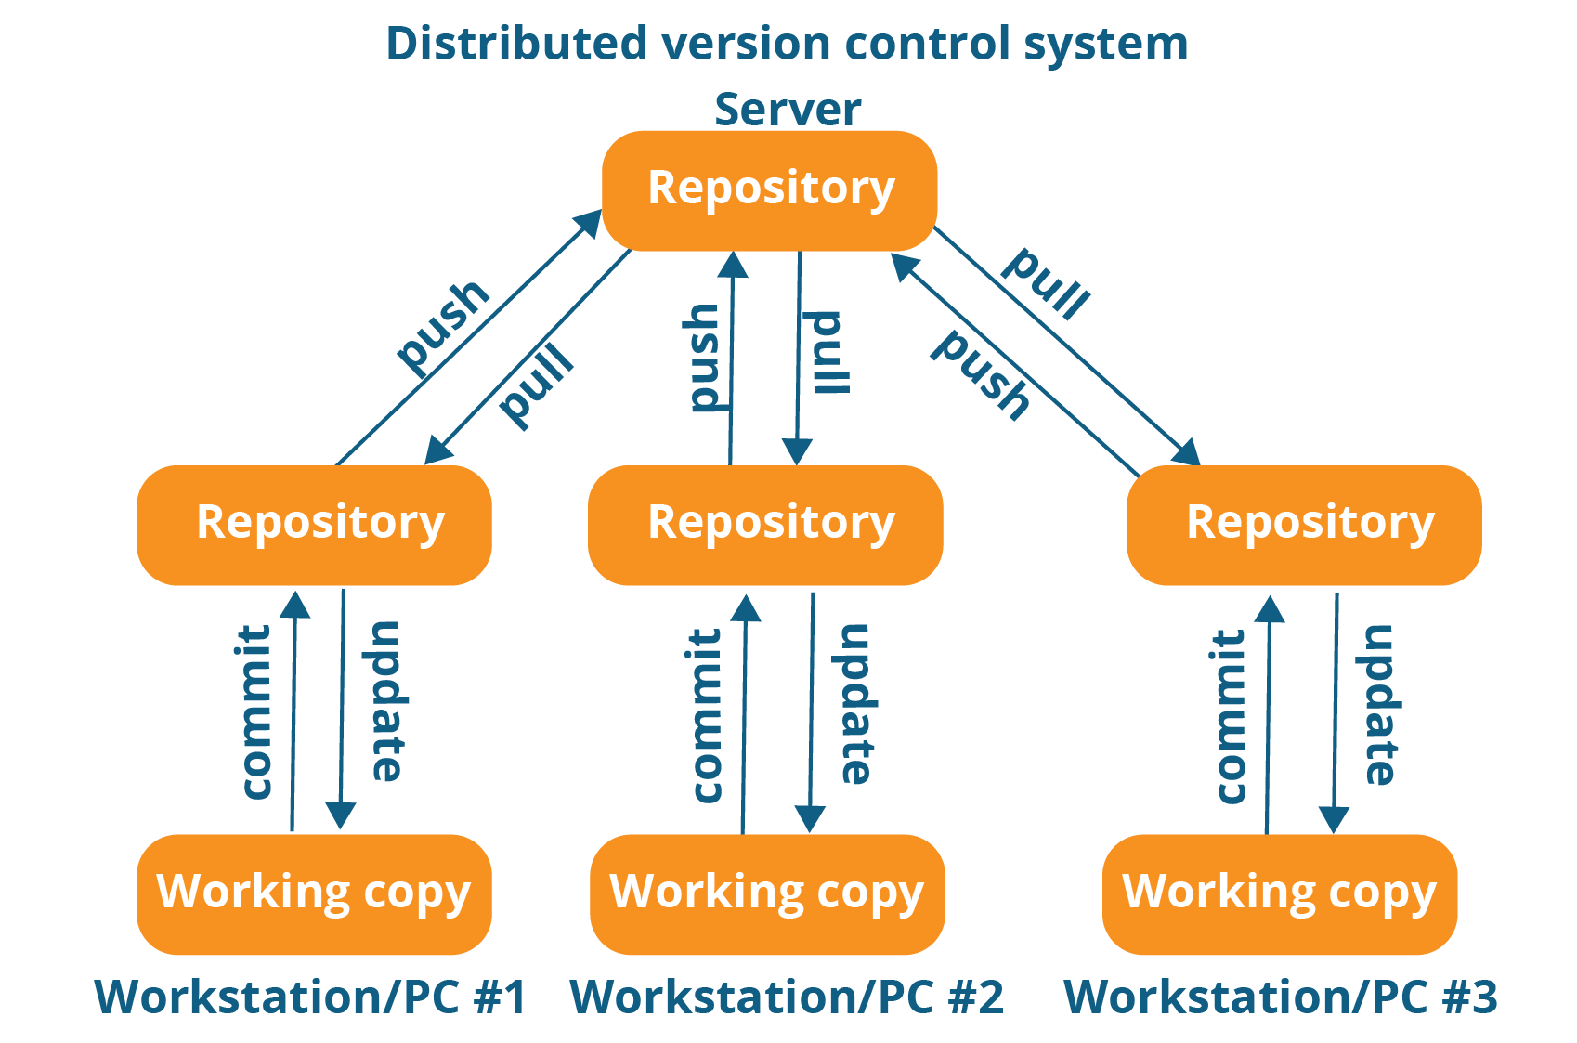
As you can see in the above diagram, every programmer maintains a local repository on its own, which is actually the copy or clone of the central repository on their hard drive. They can commit and update their local repository without any interference.
They can update their local repositories with new data from the central server by an operation called “pull” and affect changes to the main repository by an operation called “push” from their local repository.
The act of cloning an entire repository into your workstation to get a local repository gives you the following advantages:
- All operations (except push & pull) are very fast because the tool only needs to access the hard drive, not a remote server. Hence, you do not always need an internet connection.
- Committing new change-sets can be done locally without manipulating the data on the main repository. Once you have a group of change-sets ready, you can push them all at once.
- Since every contributor has a full copy of the project repository, they can share changes with one another if they want to get some feedback before affecting changes in the main repository.
- If the central server gets crashed at any point of time, the lost data can be easily recovered from any one of the contributor’s local repositories.
After knowing Distributed VCS, its time we take a dive into what is Git.

What Is Git?
Git is a Distributed Version Control tool that supports distributed non-linear workflows by providing data assurance for developing quality software. Git provides with all the Distributed VCS facilities to the user that was mentioned earlier. Git repositories are very easy to find and access.
The features mentioned below:
1. Free and open source: 2. Speed: 3. Scalable: 4. Reliable:
5. Secure: 6. Economical: 7. Supports non-linear development:
8. Easy Branching: 9. Distributed development:
10. Compatibility with existing systems or protocol

What is Git – Role Of Git In DevOps?
Now that you know what is Git, you should know Git is an integral part of DevOps. DevOps is the practice of bringing agility to the process of development and operations.
DevOps promotes communication between development engineers and operations, participating together in the entire service life-cycle, from design through the development process to production support.
The diagram below depicts the Devops life cycle and displays how Git fits in Devops.

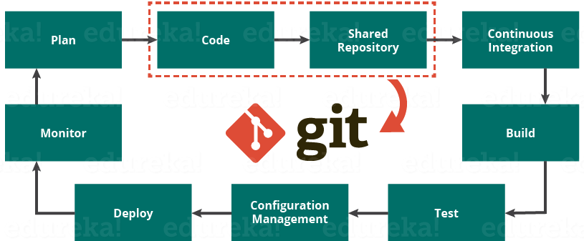

Companies Using Git
Git has earned way more popularity compared to other version control tools available in the market like Apache Subversion(SVN), Concurrent Version Systems(CVS), Mercurial etc. You can compare the interest of Git by time with other version control tools with the graph collected from Google Trends below:
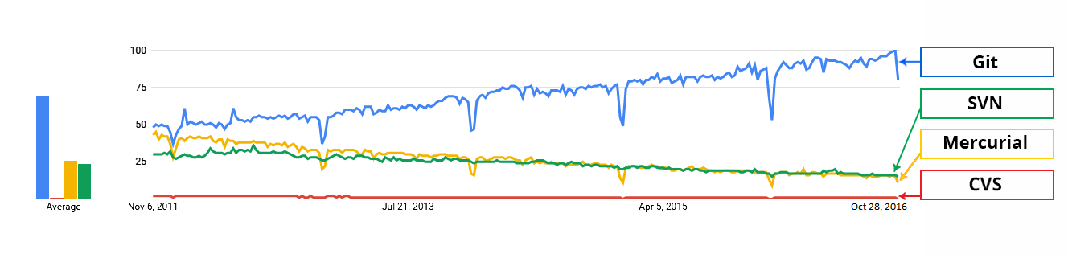
In large companies, products are generally developed by developers located all around the world. To enable communication among them, Git is the solution.
Some companies that use Git for version control are: Facebook, Yahoo, Zynga, Quora, Twitter, eBay, Salesforce, Microsoft and many more.

Git Tutorial – Commands And Operations In Git
In this Git Tutorial, you will learn:
- Commands in Git
- Git operations
- And some tips and tricks to manage your project effectively with Git.
Before starting with the commands and operations let us first understand the primary motive of Git.
The motive of Git is to manage a project or a set of files as they change over time. Git stores this information in a data structure called a Git repository. The repository is the core of Git.
To be very clear, a Git repository is the directory where all of your project files and the related metadata resides.
Git records the current state of the project by creating a tree graph from the index. It is usually in the form of a Directed Acyclic Graph (DAG).

Git Tutorial – Operations & Commands
Some of the basic operations in Git are:
- Initialize
- Add
- Commit
- Pull
- Push
Some advanced Git operations are:
- Branching
- Merging
- Rebasing
Let me first give you a brief idea about how these operations work with the Git repositories. Take a look at the architecture of Git below:
Let me first give you a brief idea about how these operations work with the Git repositories. Take a look at the architecture of Git below:
